Date – 29/08/2022

Assignment 6

Code

/\*take one 2D array from the user.Represent that in both row-major and column-major representation\*/

#include<stdio.h>

int main(){

/\*2D array declaration \*/

int disp[2][3];

/\*Counter variable for the loop\*/

int i,j;

for(i=0; i<2; i++){

for(j=0;j<3;j++) {

printf("Enter value of disp[%d][%d]:", i, j);

scanf("%d",&disp[i][j]);

}

}

//Displaying array elements

printf("Two Dimensional array elements:\n");

for(i=0; i<2; i++){

for(j=0;j<3;j++) {

printf("%d", disp[i][j]);

if(j==2) {

printf("\n");

}

}

}

return 0;

}

Output

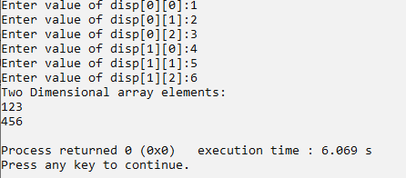

Assignment – 7

Code

/\*check whether a matrix is sparse matrix or not\*/

#include <stdio.h>

void main()

{

static int array[10][10];

int i, j, m, n;

int counter =0;

printf("Enter the order of the matrix\n");

scanf("%d %d", &m,&n);

printf("Enter the co-efficient of the matrix \n");

for (j=0; i < m; ++i)

{

for (j = 0; j < n; ++j)

{

scanf("%d", &array[i][j]);

if (array[i][j] == 0)

{

++counter;

}

}

}

if (counter > ((m \* n) / 2))

{

printf("The given matrix is sparse matrix \n");

}

else

printf("The given matrix is not a sparse matrix \n");

printf("There are %d number of zeros", counter);

}

Output

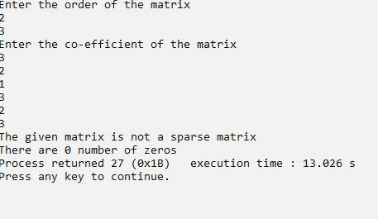

Assignment – 8

Code

#include<stdio.h>

int main(){

printf("enter the data in 2D array\n");

int r,c;

printf("enter the row of matrix");

scanf("%d",&r);

printf("enter the column of matrix");

scanf("%d",&c);

int arr[r][c];

int i,j,count=0;

for(i=0;i<r;i++){

for(j=0;j<c;j++){

printf("\n enter number for position [%d][%d] = ",i,j);

scanf("%d",&arr[i][j]);

if(arr[i][j]==0){

count=1+count;

}

}

}

printf("\matrix\n");

for(i=0;i<c;i++){

for(i=0;i<r;i++){

for(j=0;j<c;j++){

printf("%d\t",arr[i][j]);

}

printf("\n");

}

printf("\n transpose \n");

for(i=0;i<c;i++){

for(j=0;j<r;j++){

printf("%d\t",arr[j][i]);

}

printf("\n");

}

if(count>r\*c/2){

printf("this is a sparse matrix");

}else

{

printf("this is not a sparse matrix");

}

}

}

Output

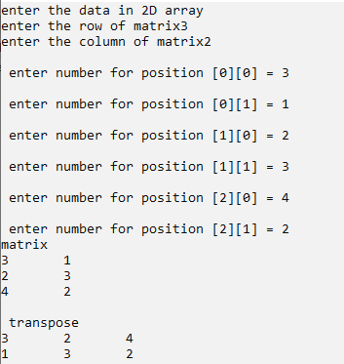

Assignment – 9

Code

#include<stdio.h>

int main(){

int a[10][10],b[10][10],c[10][10],n,i,j,k;

printf("Enter the value of N (N <=10): ");

scanf("%d",&n);

printf("Enter the elements of Matrix-A: \n");

for(i=0;i<n;i++)

{

for(j=0;j<n;j++)

{

scanf("%d",&a[i][j]);

}

}

printf("Enter the elements of Matrix-B: \n");

for(i=0;i<n;i++)

{

for(j=0;j<n;j++)

{

scanf("%d",&b[i][j]);

}

}

for(i=0;i<n;i++)

{

for(j=0;j<n;j++)

{

c[i][j]=0;

for(k=0;k<n;k++)

{

c[i][j]+=a[i][k]\*b[k][j];

}

}

}

printf("The product pf two matrices is: \n");

for(i=0;i<n;i++)

{

for(j=0;j<n;j++)

{

printf("%d\t",c[i][j]);

}

printf("\n");

}

return 0;

}

Output

